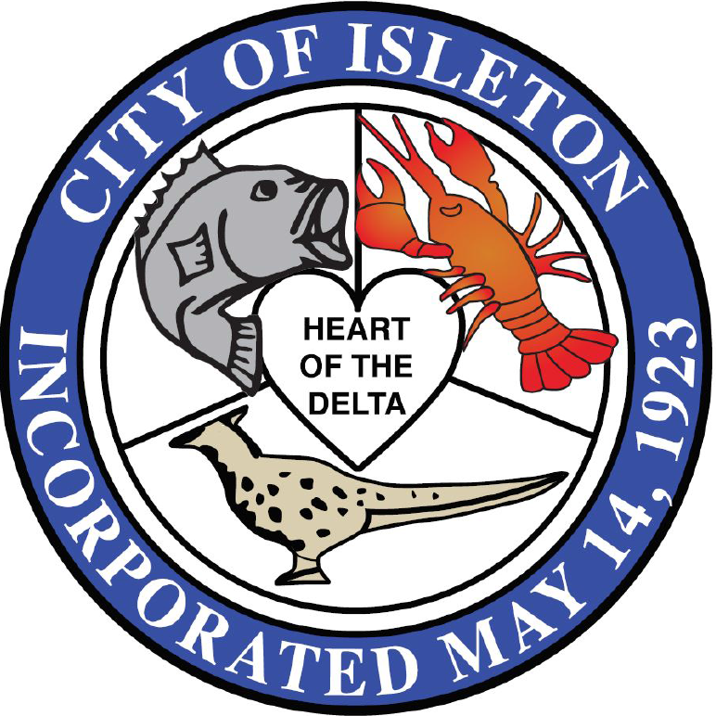
CITY OF ISLETON NEWSLETTER
  - Volume 3 / Issue 2 / Mar. 01, 2022

MAKE A DIFFERENCE BY REPORTING SUSPICIOUS ACTIVITY.

Call 911 for the Sheriff’s
Non-Emergency
916-874-5115 press 0
City Hall Phone 916-777-7770
_______________________
Delta Region GHAD

The City Council recently formed the Delta Region Geologic Hazard Abatement District (DRGHAD). This district will provide active flood protection, reduce flood insurance rates for homes, and provide emergency funds directly to households in a natural disaster like a flood. During its initial year the DRGHAD will be establishing its operations and financing. The first board meeting will be March 29, 2022 at 6:30pm

Parking Enforcement Hotline

To report abandoned vehicles or vehicles violating parking rules call (916) 777-7770.

covid 19 virus update

On February 16, 2022 the County issued new health orders. First Order rescinded the County order directing all individuals to wear face coverings indoor workplaces and public settings. The Second Order rescinded the County Order directing all public meetings occur virtually. The City is complying with the County health orders.

city SCHEDULE

      - Planning Commission Meeting Tue, Mar 1st 6:30pm (Canceled)
      - City Council Meeting Tue, Mar 8th at 6:30 pm
      - Measure B Oversight Committee Meeting, Wed Mar 16th at 6:30pm
      - City Council Meeting Tue, Mar 22nd at 6:30 pm
      - Delta Region GHAD Board Meeting Tue, Mar 29th at 6:30 pm

community information

LIONS CLUB EASTER EGG HUNT: Annual Easter Egg Hunt is back in April. Exact date will be announced.

CREDIT CARD SEWER PAYMENTS: Residents can make payments via City website. Goto: https://cityofisleton.com/bill-pay/.

PARKING ENFORCEMENT: The City is enforcing basic parking and vehicle code rules. Please be aware of parking rules, parking signs, parking zones and fire lanes.

COUNTY REPORT ON CITY ELECTION: On February 16, 2022 the City received direction from the County to take action to fill the fifth Council seat. The City has initiated actions to meet this direction. For further information contact City Hall.

city public works projects

UPCOMING PUBLIC WORKS PROJECTS: Staff is working on rehabilitating Main Street including new pedestrian lights. There will also be a series of hearings on proposed new City facilities at the corner of 2nd and A Streets.

On February 10th, the City received approval by the State Boating & Waterways Commission for Boat Ramp development funds in the amount of $200,000

Also last month, the City received $100,000 grant for pedestrian lighting on Main Street from the Sacramento Housing and Development Agency (SHRA).

SACOG Grants: Last month the City received a grant to initiate it’s rental housing inspection program. The Grant amount is $40,000. The City also received the SACOG Managed Funds to complete the 4th Phase of the General Plan Update, Community Design Fund for Main Street.

FIRE FIGHTER VOLUNTEERS: Isleton Fire Department is accepting resumes to help fill both volunteer and reserve firefighter positions. If interested, please fax resume to 916-777-7775 or drop one off in person at 101 2nd Street, Isleton, CA 95641-0716.

